Mitosis Homework
Q1) Give three reasons why Mitosis is important.
- Draw and label your diagram showing a chromosome, a section of a chromosome showing where the genes are and colour these in.
- ………………………………………………………………………………………………………
- ……………………………………….……………………………………………………………..
- ………………………………………………………………………………………………………
Q2) Mitosis involves what type of reproduction?
…………………………………………………………………………..……………………………..
Q3) True or false: There are 20 pairs of chromosomes in a human cheek cell?............................................................................................
Q4) Explain what is happening in these diagrams of Mitosis.
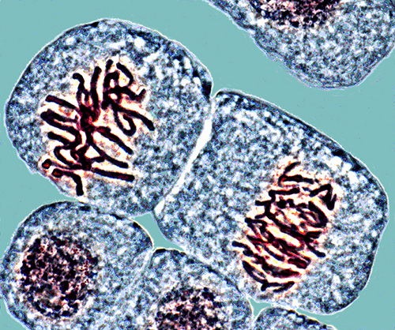
…………………………………………………………………………..……………………………..
…………………………………………………………………………..……………………………..
…………………………………………………………………………..……………………………..
Extension.
- Describe the process of Mitosis using the above diagrams to help.
…………………………………………………………………………..…………………………….…………………………………………………………………………..……………………………..
…………………………………………………………………………..……………………………..
…………………………………………………………………………..……………………………..
…………………………………………………………………………..……………………………..
…………………………………………………………………………..……………………………..
…………………………………………………………………………..……………………………..
…………………………………………………………………………..……………………………..
…………………………………………………………………………..……………………………..
…………………………………………………………………………..……………………………..

- Research what would happen if Mitosis went wrong.
…………………………………………………………………………..……………………………..
…………………………………………………………………………..……………………………..
…………………………………………………………………………..……………………………..
…………………………………………………………………………..……………………………..
…………………………………………………………………………..……………………………..
…………………………………………………………………………..……………………………..
…………………………………………………………………………..……………………………..
…………………………………………………………………………..……………………………..
…………………………………………………………………………..……………………………..

Diffusion Homework (2016) by C. Watson, English Martyrs’ Catholic School shared under a CC-BY 4.0 (Creative Commons Attribution 4.0 International License ) licence. Image from flickr.com

